Nume: Sabou

Prenume: Sergiu-Raul

[sabou.da.sergiu@student.utcluj.ro](mailto:sabou.da.sergiu@student.utcluj.ro)

Poza:

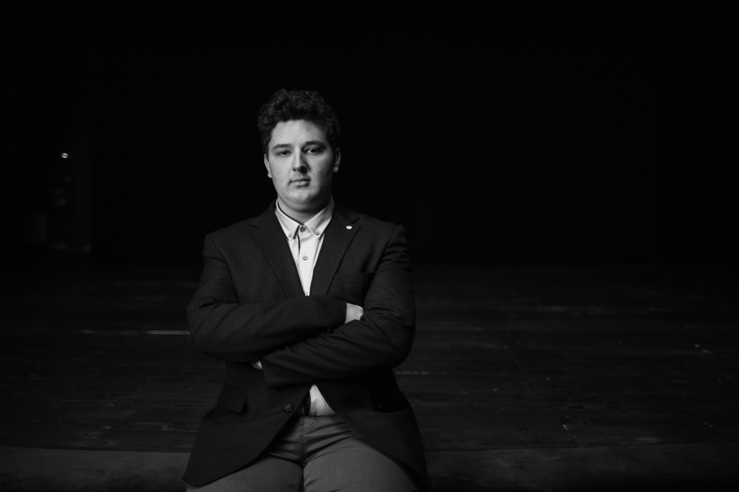

Citat: “It is common sense to take a method and try it. If it fails, admit it frankly and try another. But above all, try something.” - Franklin D. Roosevelt

Materii de interes:

Tehnici CAD: An II, Semestrul II, <https://etti.utcluj.ro/files/Acasa/Site/FiseDisciplina/EaRo/28.pdf>

Inginerie software: An II, Semestrul II, <https://etti.utcluj.ro/files/Acasa/Site/FiseDisciplina/EaRo/29.pdf>

Grafică asistată de calculator: An II, Semestrul I, <https://etti.utcluj.ro/files/Acasa/Site/FiseDisciplina/EaRo/15.pdf>

Arhitectura microprocesoarelor: An III, Semestrul I, <https://etti.utcluj.ro/files/Acasa/Site/FiseDisciplina/EaRo/31.pdf>

Sisteme cu FPGA: An IV, Semestrul I, <https://etti.utcluj.ro/files/Acasa/Site/FiseDisciplina/EaRo/49_10.pdf>

Hobby:

* Gaming
* Programare
* Istorie